**DATABASE DESIGN**

**BROKERS EVALUATION**

FE_MT_Criteria

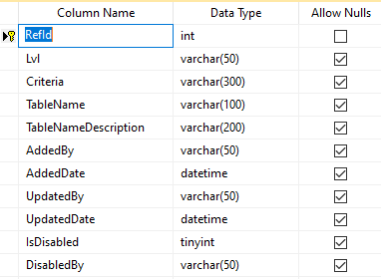

FE_MT_Forwarders

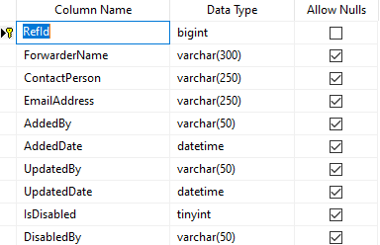

FE_TRANSACTION_RequestDetails

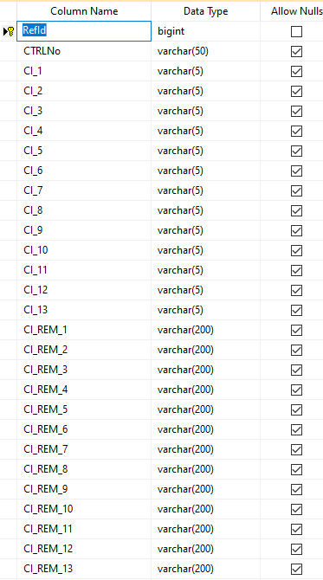

FE_TRANSACTION_RequestHead

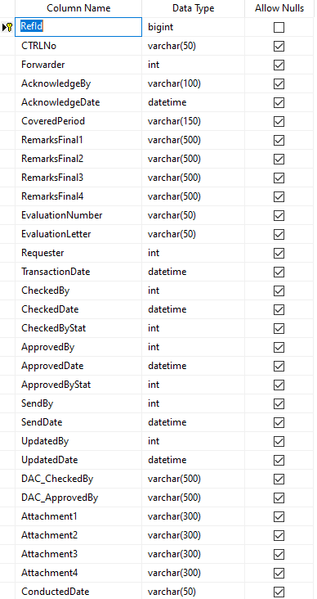

FE_TRANSACTION_Schedules

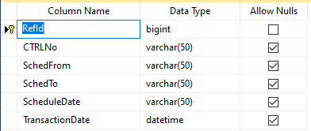

**MATERIAL REGISTRATION**

IMR_MT_3TG

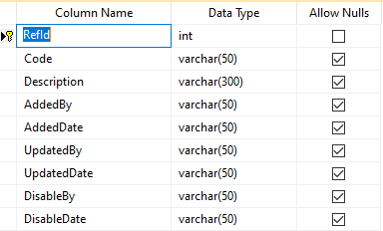

IMR_MT_Asset_Type



IMR_MT_Auto_Order_Suspension



IMR_MT_BCP_Management



IMR_MT_BusinessType



IMR_MT_Incoterms



IMR_MT_ItemClassCode



IMR_MT_QuantityUnit



IMR_MT_RemarksReason



IMR_MT_TaxType



IMR_TRANSACTION_Details

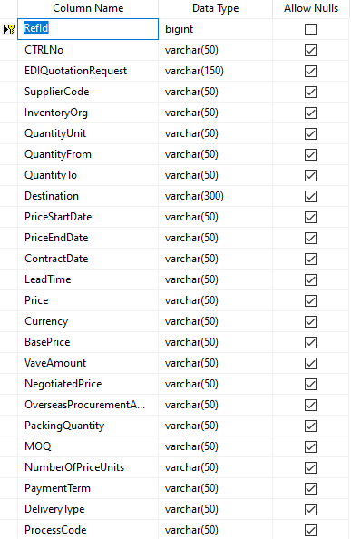

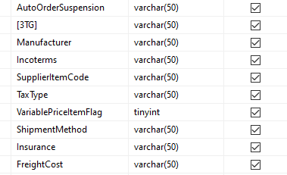

IMR_TRANSACTION_Head

